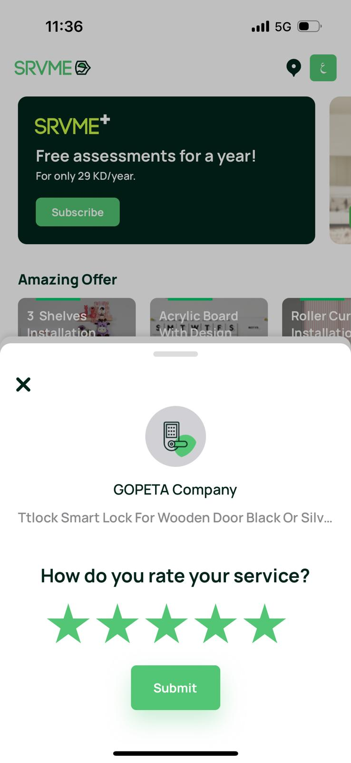

It happen with me number account number 96666799 my last order was electrical order number 78792

But it asked me to rate an order where I have done it long time ago I have another issue that i can’t find the order in my order history

* What is the process if there is multiple order which is been not rated

WE FOUND ANOTHER ISSUE THAT THERE IS SOME ORDER WHICH IHAVE DONE NOT SHOWING IN MY APP order number 769192 , 73790 , 73788 , 73107

